Name: ______________ IPAD # ________

Topic #12

PHYSICAL AND CHEMICAL

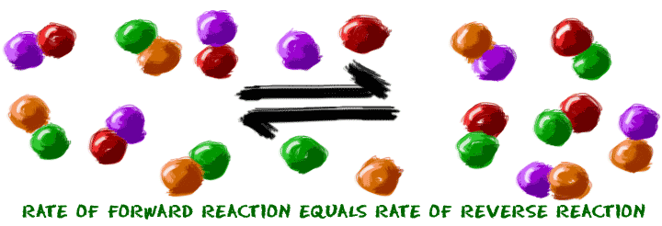EQUILIBRIUM

TEXTBOOK: CHAPTER 18

Answer Key

**STUDENT OUTLINE AND STUDY GUIDE:**

**I. WHAT IS EQUILIBRIUM?**

Dynamic equilibrium occurs when the rate of the forward reactions EQUALS the rate of the reverse reaction. Reverse reactions are noted with a double-headed arrow.

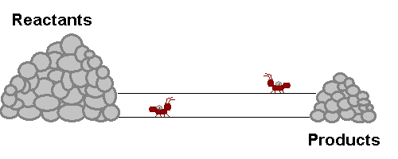

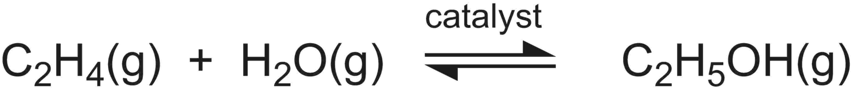

The sign that equilibrium has been reached is that the amounts/concentrations of reactants and products are constant NOT necessarily equal. In order to reach equilibrium, the reactants and products must be in a closed system or container otherwise substances may escape.

EQUAL RATES CONSTANT CONCENTRATION

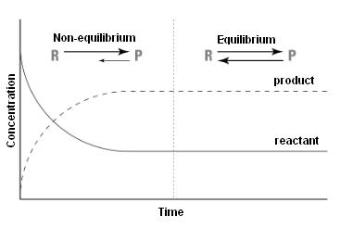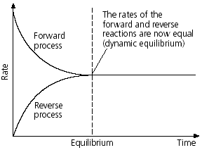

**II. TYPES OF EQUILIBRIA IN A CLOSED SYSTEM:**

**1. PHASE EQUILIBRIUM**

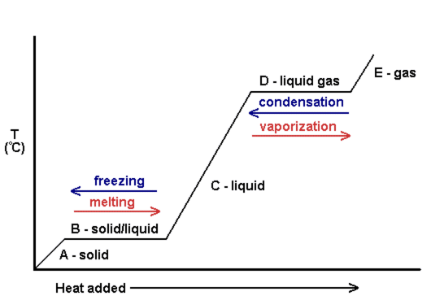

a. Equilibrium is reached when the rate of melting equals the rate of freezing at the melting point/freezing point temperature.

b. Equilibrium is reached when the rate of vaporization equals the rate of condensation at the boiling point/condensation point temperature.

**2. SOLUTION EQUILIBRIUM**

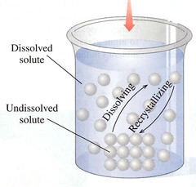 Equilibrium is reached when the rate of dissolving equals the rate of crystallization in a **SATURATED** solution.

**NaCl(s) <-> Na+(aq) + Cl-(aq)**

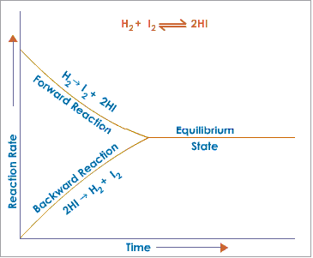

**3. CHEMICAL EQULIBRIUM**

The rate of synthesis of hydrogen iodide

from its elements equals the rate of

decomposition of hydrogen iodide into its

elements.

**III. LAW OF CHEMICAL EQUILIBRIUM**

A reaction at equilibrium can be represented by the following equation:

aA + bB <----> cC + dD

*Note: small letters represent coefficients in a balanced equation and the capital letters represent chemical formulas in a reaction.*

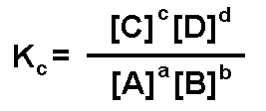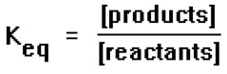

**The rules from converting from converting a chemical equation into a mathematical equation are:**

1. [products] / [reactants]

2. brackets means “concentration of”

3. Coefficients (moles) become exponents

4. do not include solids or pure liquids in the equilibrium expression

**The Keq value measures the extent of the reaction.**

A **large K** value indicates a reaction that favors **products** (shift right)

A **small K** value indicates a reaction that favors **reactan**ts (shift left)

**IV. LeChatelier’s Principle:**

If a system at equilibrium is subject to **stress**, the system will shift so that the stress is relieved. The shift will result in a net increase or decrease in the substances of the system.

*A **shift right** will cause an **increase** in **products** and **decrease** in **reactants**.

**A **shift left** will cause a **decrease** in **products** and **increase** in **reactants**

A stress on a system is any factor that can affect the rate of a chemical change. In topic #8, Kinetics (Chapter 18), we studied the factors that can affect the rate of a chemical reaction or physical change. These factors are temperature, pressure (gases only!), concentration, surface area of a solid, and a catalyst. These factors are the same stresses that can cause a reversible reaction to shift more to the right or left.

**Summary of Chemical Stresses on Equilibrium**

|  |  |
| --- | --- |
| **STRESS** | **AFFECT** |
| **TEMPERATURE** | * **Increase** temperature favors an **endothermic** reaction * **Decrease** temperature favors an **exothermic** reaction |
| **PRESSURE** | * **Increase pressur**e favors the direction of the reaction that produces **less moles** of gas. * **Decrease** **pressu**re favors the direction of the reaction that produces **more moles** of gas. |
| **CONCENTRATION** | * **Increase concentration** of one   substance in a system favors the direction of the reaction that **reduces** the excess amount.   * **Decrease concentration** of one   substance in a system favors the direction of the reaction that **replaces** the missing substance. |
| **COMMON ION EFFECT**  ***Solution Equilibrium*** | * Increase concentration of an ion favors crystallization and a decrease in solubility of the salt. * Decrease concentration of an ion favors dissolving and an increase in solubility of the salt. |
| **CATALYST** | Adding a catalyst affects opposing reactions equally; no net change in equilibrium or the value of Keq. Equilibrium is reached more quickly. **NO SHIFT!!** |

**HOMEWORK PACKET**

**Part I-WHAT IS EQUILIBRIUM?**

Using the glossary in the textbook, define the following terms:

**Chemical reaction:**

A change in which one or more reactants change into one or more products; characterized by the breaking of bonds in reactants and the formation of bonds in products.

**Chemical Equilibrium:**

A state of balance in which the rates of the forward and reverse reactions are equal; no net change in the amount of reactants and products occurs in the chemical system.

**Page 610**

**INTERPRET GRAPHS-**FIGURE 18.13

a. Initial concentrations are at the far left, and equilibrium concentrations are at the far right.

b. SO3

c. No, as long as the reaction conditions are the same, the equilibrium concentrations are the same.

**Page 620**

#25 There is not a net change in the amounts of reactants or products.

**Page 638**

#63 In a reversible reaction, reactants are continually forming products and products are continually forming reactants.

**Part II-TYPES OF EQUILIBRIA IN A CLOSED SYSTEM**

**Write a balanced equation that represents each type of equilibrium. Search using the Internet, textbook or class notes for appropriate examples.** \****Do not use examples listed in the study guide.***

|  |  |
| --- | --- |
| **Type of Equilibrium** | **Balanced Equation** |
| **Phase Equilibrium** | NH3(l) <--> NH3(g) |
| **Solution Equilibrium** | KNO3(s) <--> KNO3(aq) |
| **Chemical Equilibrium** | 2SO2(g) + O2(g) <--> 2SO3(g) |

**Part III LAW OF CHEMICAL EQUILIBRIUM**

Using the glossary in the textbook, define the following term:

**Equilibrium Constant (Keq):**

The ratio of product concentrations to reactant concentrations at equilibrium, with each concentration raised to a power equal to the number of moles of that substance in the balanced chemical equation.

**Page 620**

#27 For a large Keq, products dominate the reaction mixture; for a small Keq, reactants dominate the reaction mixture.

#30 a; At large Keq values, products dominate the reaction mixture at equilibrium.

**Extent of the reaction: Fill in the chart below with either “high/relatively large number” or “low/relatively small number”**

|  |  |  |
| --- | --- | --- |
| **Keq** | **Equilibrium concentrations or moles of reactants** | **Equilibrium concentrations or moles of products** |
| **Relatively large**  **K>10** | Relatively **low** number | Relatively **high** number |
| **Relatively small**  **K<0.1** | Relatively **high** number | Relatively **low** number |

**Page 617-618**

|  |  |
| --- | --- |
| #19  Keq = 12 | #21  Keq = 1.6 x 10-3 |
| #20  Keq = 8.4 x 10-2 | #22  Keq = 0.79 |

**Page 638**

#66 a. Keq = [H2S]2 [CH4] b. Keq = [PCl3] [Cl2]

[H2] [CS2] [PCl5]

#67 a. highly favorable b. favorable c. highly unfavorable

#90 Keq = [SO3]2

[SO2] [O2]

#91 (Include equilibrium expression for this reaction)

Keq = [CO] [H2O] Keq = 6.59 X 10 -1

[CO2] [H2]

**Part IV LeChatelier’s Principle**

Using the glossary in the textbook, define the following term:

**Le Chatelier’s Principle:**

When a stress is applied to a system in dynamic equilibrium, the system changes in a way that relieves the stress.

**Page 620**

#26 -Changes is the concentration of reactants and products

- Changes in pressure (gases only)

- Changes in temperature

#28 No; only in reversible reactions in which the mole ratios of gases reactants and products are unequal.

#32 They will know how to manipulate concentrations, temperature, and pressure to increases the percent yield of the reaction.

**Page 615**

#17 a. favors products

b. favors products

c. favors reactants

d. favors reactants

#18 a. favors reactants

b. favors reactants

c. favors products

d. favors products

**Page 626**

#37 The smaller the Keq value, lower the solubility of the compound.

#39 Ksp = [Ag+]2 [CO32-]

#45 Adding a common ion (a product in the dissolution expression) disturbs the equilibrium and causes a shift toward the reactant side of the expression.

**Page 638 – 639**

#70 a. [Ni2+] [S2-] = Ksp b. [Ba2+] [CO32-] = Ksp

# 71 c, b, d, a

#72 It lowers the solubility of the ionic compound.

#82 Carbonated drinks in closed containers are in a state of dynamic equilibrium between the CO2 in the liquid state and above the liquid. When the container is opened, CO2 gas above the liquid escapes. The gas bubbles, out of the liquid in attempt to reestablish equilibrium.

**Pearsons SuccessNet On-line**

**The Chemistry of Diabetes**

Understand Diabetes by watching the video online.

1. Complete the following reaction:

glucose + protein <--->

2. How is Le Chatelier’s principle used to control diabetes?

**________________________________________________________________**

**__________________________________________________________________**

**Complete the following chart by writing left, right or none for “equilibrium shift” and decreases, increases or remains the same for the “concentrations” of reactants and products and for the value of K.**

**Synthesis of Hydrogen Iodide**

**H2(g)  + I2(g) + 52.7 kJ <-----> 2HI(g)**

|  |  |  |  |  |  |
| --- | --- | --- | --- | --- | --- |
| **Stress** | **Equilibrium**  **Shift** | **[H2]** | **[I2]** | **[HI]** | **K value** |
| **Add H2** | Right | ⬆⬇ | ⬇ | ⬆ | No change |
| **Add I2** | Right | ⬇ | ⬆⬇ | ⬆ | No change |
| **Add HI** | Left | ⬆ | ⬆ | ⬆⬇ | No change |
| **Remove H2** | Left | ⬇⬆ | ⬆ | ⬇ | No change |
| **Remove I2** | Left | ⬆ | ⬇⬆ | ⬇ | No change |
| **Remove HI** | Right | ⬇ | ⬇ | ⬇⬆ | No change |
| **Increase**  **Temperature** | Right | ⬇ | ⬇ | ⬆ | ⬆ |
| **Decrease**  **Temperature** | Left | ⬆ | ⬆ | ⬇ | ⬇ |
| **Increase**  **Pressure** | No  Shift | ____ | _____ | _____ | No change |
| **Decrease**  **Pressure** | No  Shift | ____ | _____ | ____ | No change |

Macintosh HD:Users:alicezagelbaum:Desktop:chemmatters-sept2005-equilibrium.pdf





Answer the following questions related to the article “What’s So Equal About Equilibrium?”

1. Describe the two things that are happening that describe the “dynamic equilibrium” involving chlorine within a fish tank.

- Chlorine is leaving the fish tank to mix with the air molecules in the room.

- Some molecules of chlorine gas near the surface of the tank may dissolve

back into the water.

After a couple of days, rate of chlorine molecules leaving and entering the tank water is equal and the concentration of chlorine molecules remains constant.

2. Why is the reaction of hydrogen and oxygen to form water written as a completion reaction with a single arrow?

The formation of water produces a very stable product and would require energy (electrolysis) to decompose water into its reactants.

3. Why is the reaction of hydrogen and nitrogen to form ammonia always written as a reversible reaction with a double arrow?

Equilibrium is reached well before the reactants are consumed.

3. What is the function of the earth’s ozone layer?

It absorbs and screens out a portion of ultraviolet rays coming from the sun.

4. What creates ozone in the stratosphere?

When ultraviolet light from the sun breaks a molecule of oxygen (O2) into its atomic form (O), it can collide with another molecule of O2 to form ozone (O3).

5. Name two catalysts that break ozone down in the stratosphere.

-Bromine

-Chlorine